PASTA WITH SWISS CHARD BACON AND LEMONY RICOTTA Recipe by dicentra

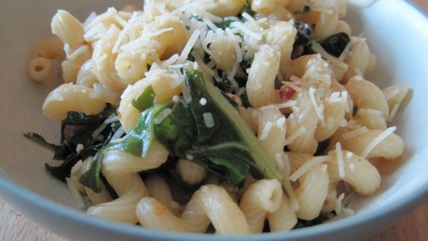
INGREDIENTS

1 lb corkscrew macaroni

2 tablespoons olive oil

5 slices bacon, coarsely chopped

3 garlic cloves, chopped

1 small yellow onion, chopped

¹⁄₂ teaspoon red pepper flakes

1 bunch swiss chard, cleaned and coarsely

chopped

1 cup vegetable stock

1 cup ricotta cheese

1 lemon, juice and zest of

1/4 cup parmesan cheese, grated

DIRECTIONS
- Bring a large pot of water to a boil for the pasta. When the water comes to a boil, add salt and cook the pasta al dente.
- While the pasta cooks, preheat a large skillet over moderate heat. Add the olive oil and bacon, and cook until the bacon crisps, about 3 minutes.
- To the bacon add the garlic, onions, salt, pepper and red pepper flakes and cook, stirring frequently, for 5 minutes or until the onions are lightly caramelized.
- Add the chopped Swiss chard, toss to coat, and wilt the chard down.
- Turn the heat up to high and add the vegetable stock. When the liquid comes to a boil, reduce the heat and simmer for 6 to 7 minutes.
- In a small bowl, combine the ricotta with the lemon zest and season with salt and pepper. Place ¼ cup of the ricotta mixture in the bottom of 4 bowls. Set aside.
- Add the lemon juice to the Swiss chard. Drain the pasta well and toss with the greens for a minute to let the juices absorb into the pasta.
- Turn the heat off and add the grated Parmesan cheese and toss to distribute. Serve immediately, dishing it up on top of the ricotta cheese. Stir before eating.
- NUTRITION INFO
- Serving Size: 1 (405) g Servings Per Recipe: 4
- AMT. PER SERVING% DAILY VALUE
- Calories: 796.7
- Calories from Fat 262 g33 %
- Total Fat 29.1 g44 %
- Saturated Fat 12.4 g62 %
- Cholesterol 62 mg20 %
- Sodium 815.7 mg33 %
- Total Carbohydrate 97.1 g32 %
- Dietary Fiber 5.6 g22 %
- Sugars 6.5 g26 %
- Protein 36.2 g72 %

